Updating VMware templates in vCenter

Steps:

1. Convert the template to a Virtual machine
2. Snapshot virtual machine for safe restore
3. Power on the Virtual machine
4. Update VMware Tools, windows patches or anything else you need to update on image
5. sysprep the virtual machine
6. Convert the Virtual machine back to a template
7. Test template

Screen shots below

Step1:

Right click template > select convert to virtual machine

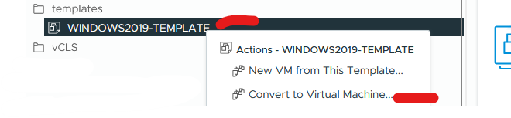

Select resource location (cluster or esxi host) > click next

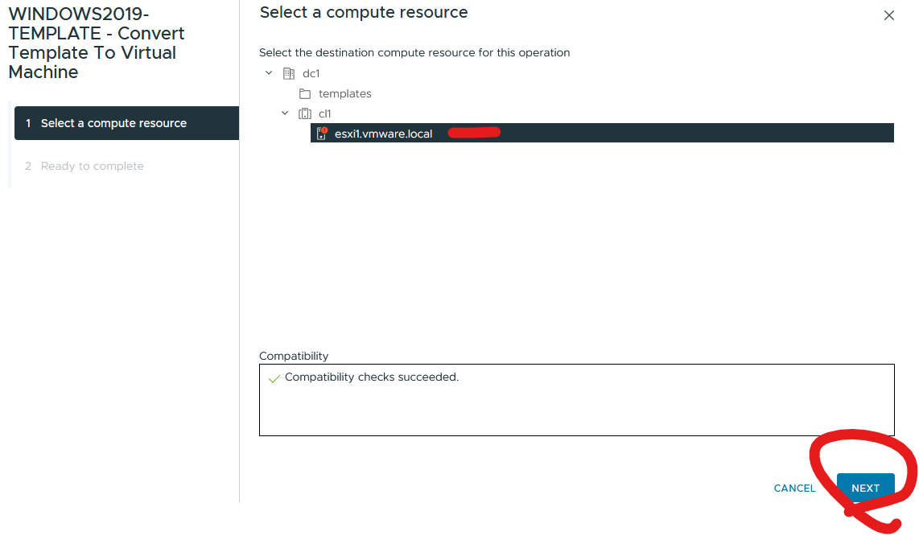

Click Finish

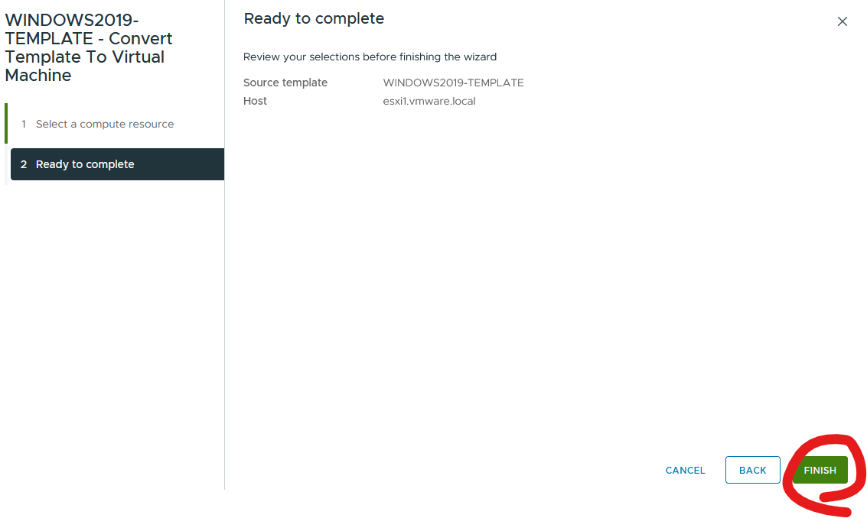

Step2:

Right click virtual machine > click take snapshot

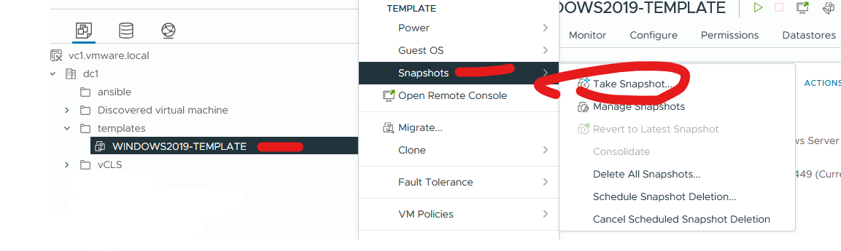

Give it a name and date > click create

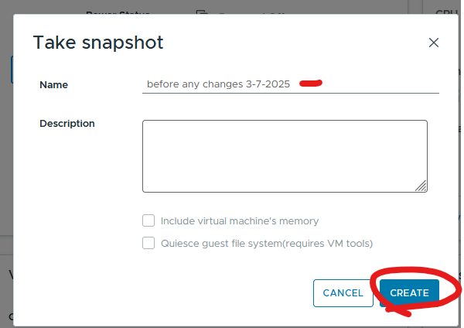

Step3:

Right click virtual machine and click power on

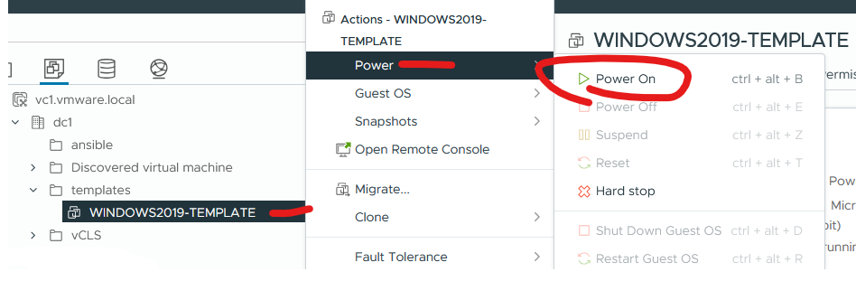

Step4:

Making changes to your machine

I am installing software chrome as an example

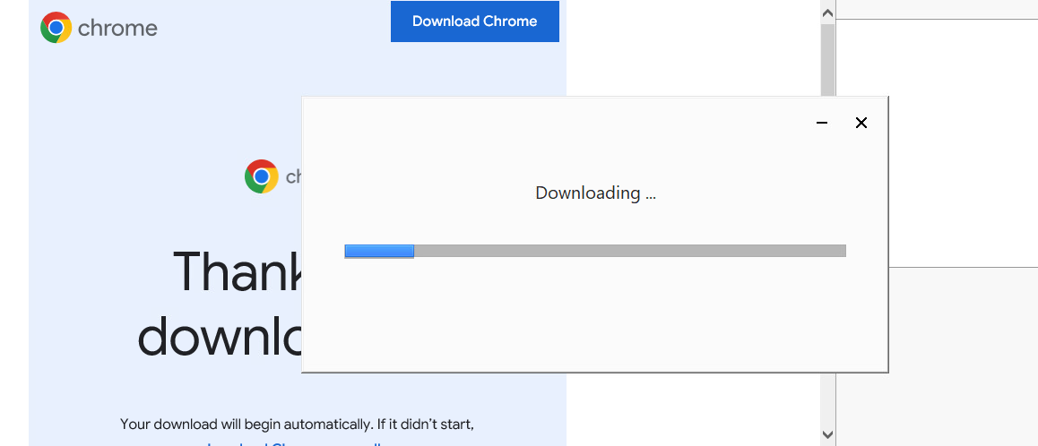

Creating a file and new account as an example

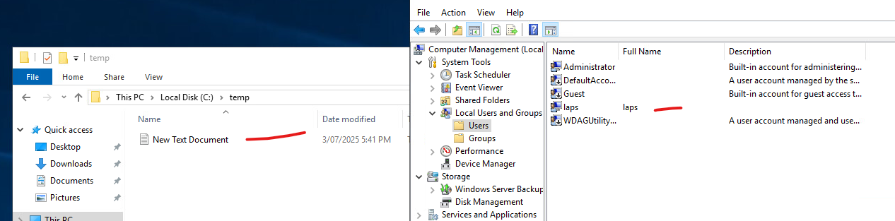

Step5:

Run sysprep

From command prompt run

cd c:\windows\system32\sysprep

sysprep.exe /generalize /shutdown /oobe

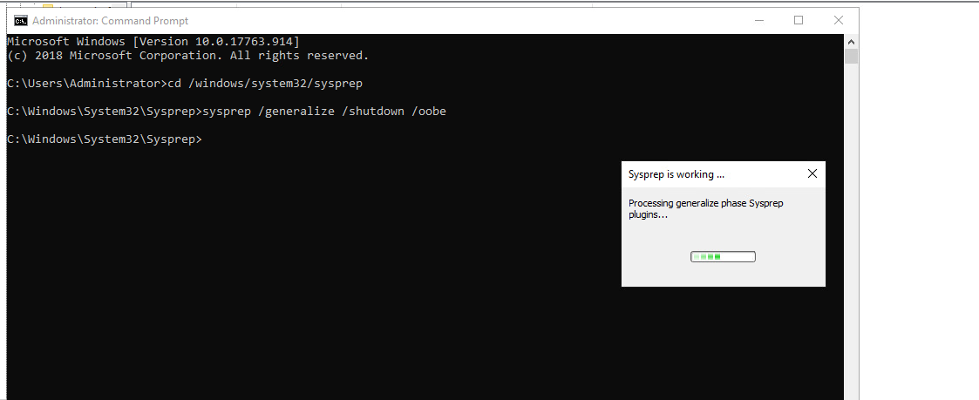

Step 6:

Right click virtual machine > covert to template

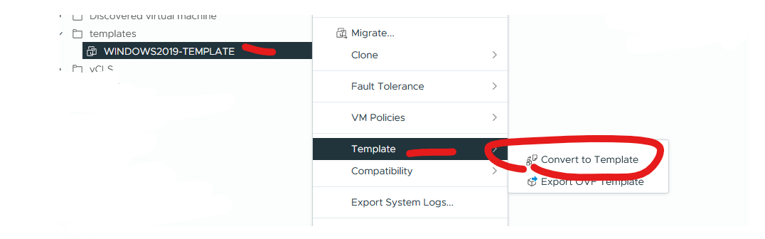

Click yes

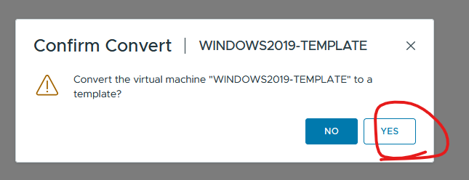



Step7:

Test deployment to ensure functioning as expected

Right click template and click new vm from this template

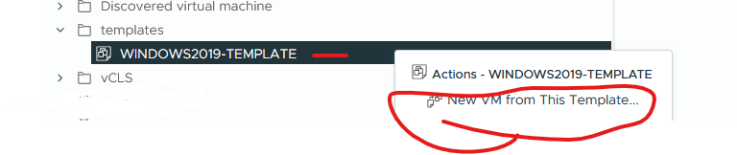

You will need to select your region, accept agreement and change your admin password. A future release will include a unattend.xml file

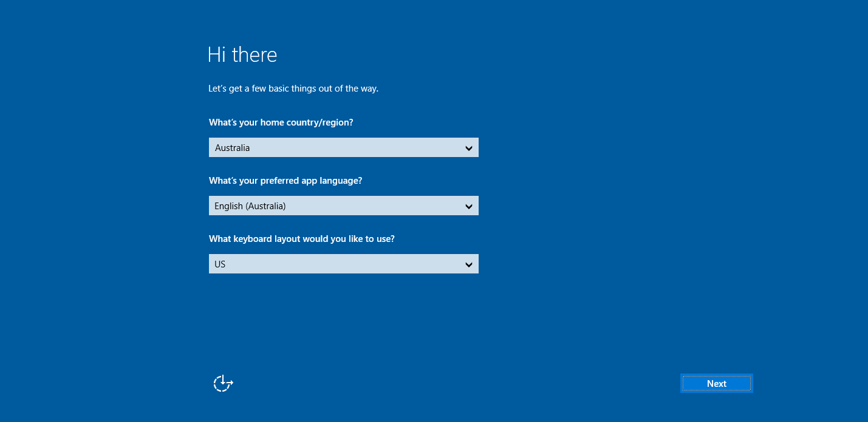

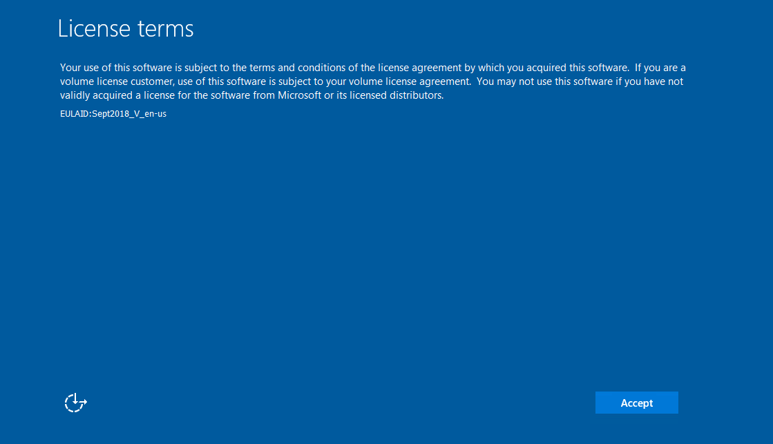

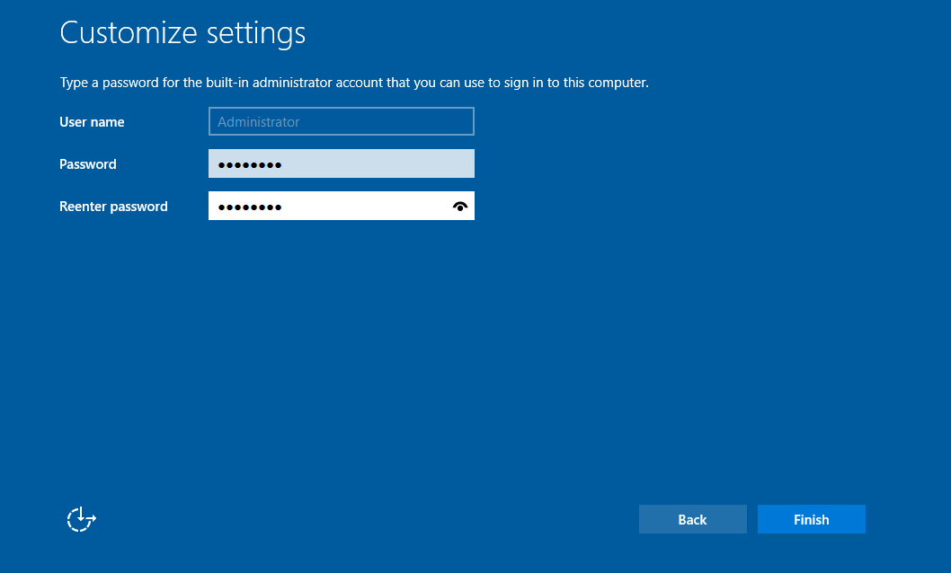

Ensure change are there

